KPR INSTITUTE OF ENGINEERING AND TECHNOLOGY
(Autonomous Institution • Affiliated to Anna University • Coimbatore - 641 407) DEPARTMENT OF COMPUTER SCIENCE AND ENGINEERING ACADEMIC YEAR: 2026 – 2027

U21CS501 – WEB TECHNOLOGY
ASSIGNMENT – 02 LABORATORY & THEORY SUBMISSION

Student Name | Ajay David Samuel
Roll Number | 24CS012
Degree & Branch | B.E. Computer Science and Engineering
Year / Semester / Section | III Year / V Semester / CSE – A
Course Code & Title | U21CS501 – Web Technology
Assignment Title | Web Systems, PHP CRUD & Java Servlets
Date | 14.10.2026

Q No: 1 | User registration form validation using JavaScript

AIM:
To design and develop a User Registration Form using HTML, CSS, and JavaScript with client-side validation. The application collects user details such as name, email, mobile number, password, gender, date of birth, city, and terms and conditions, validates the entered information using JavaScript and Regular Expressions, and displays appropriate error or success messages dynamically.

PROCEDURE:
- Create a project folder named User_Registration_Validation.
- Create three files: index.html, style.css, and validation.js.
- Design the User Registration Form using HTML5 semantic elements.
- Add input fields for Full Name, Email, Mobile Number, Password, and Confirm Password.
- Add Gender radio buttons (Male, Female, Other), Date of Birth picker, and City dropdown.
- Add a Terms & Conditions agreement checkbox.
- Add Register and Reset buttons.
- Apply CSS styling with suitable colors, fonts, spacing, borders, shadows, and hover effects.
- Create JavaScript functions to perform real-time and submission form validation.
- Access form elements using DOM methods such as getElementById() and querySelector().
- Use trim() to remove unnecessary spaces from user input values.
- Validate the Full Name and Email Address using suitable Regular Expressions.
- Validate the Mobile Number to ensure exactly 10 digits.
- Validate the Password for minimum 8 characters, uppercase, lowercase, digit, and special character.
- Verify that the Confirm Password matches the Password.
- Validate Gender selection, Date of Birth (minimum 18+ years old), City selection, and Terms & Conditions.
- Display appropriate error messages and highlight invalid fields using CSS classes.
- Prevent invalid form submission using event.preventDefault().
- Display a Registration Successful message with the user's name when all validations pass.
- Provide the Reset option to clear form values, errors, and validation styles.

HTML USED:
<!DOCTYPE
<html>
<head>
<meta>
<title>
<link>
<body>
<div>
<form>
<label>
<input>

<select>
<option>
<span>
<button>
<script>

CSS USED:
background box-sizing color
min-height font-family margin padding font-style text-align
justify-content align-items flex
width
max-width height border
border-radius border-color box-shadow display outline
font-size font-weight cursor transition
:hover @media

JAVASCRIPT:
function let const
document.getElementById() document.querySelector() document.querySelectorAll()
.value
.trim() if
else if else return
Regular Expression (RegEx) addEventListener()

event.preventDefault() textContent innerHTML classList.add() classList.remove() checked
.length new Date()
getFullYear() getMonth() getDate() isNaN() setTimeout()

index.html:
<!DOCTYPE html>
<html lang="en">
<head>
<meta charset="UTF-8">
<meta name="viewport" content="width=device-width, initial-scale=1.0">
<title>Student Admission Portal - KPRIET</title>
<link rel="stylesheet" href="style.css">
</head>
<body>
<header>
<div class="header-container">
<div class="college-info">
<h1>KPR Institute of Engineering and Technology</h1>
<p>Autonomous Institution &bull; Affiliated to Anna University &bull; Coimbatore</p>
</div>
<div class="portal-badge">Admission Portal 2026-27</div>
</div>
</header>

<main class="wrapper">
<div class="form-card">
<div class="form-title">
<h2>Student Registration Form</h2>
<p>Complete the application below with verified academic credentials and documents.</p>
</div>

<div id="alertBox" class="alert-box"></div>

<form id="registrationForm" onsubmit="return validateForm(event)" novalidate>
<fieldset>
<legend>Academic & Personal Details</legend>
<div class="row">
<div class="form-group">
<label for="fullName">Full Name <span class="required">*</span></label>
<input type="text" id="fullName" placeholder="e.g. Ajay David Samuel" required>
<small class="error-text" id="nameError"></small>
</div>
<div class="form-group">
<label for="rollNo">Roll Number / App No <span class="required">*</span></label>
<input type="text" id="rollNo" placeholder="e.g. 24CS012" required>
<small class="error-text" id="rollError"></small>
</div>
</div>

<div class="row">
<div class="form-group">
<label for="email">Institutional / Personal Email <span class="required">*</span></label>
<input type="email" id="email" placeholder="ajay.david@kpriet.ac.in" required>
<small class="error-text" id="emailError"></small>
</div>
<div class="form-group">
<label for="course">Admitted Degree & Branch <span class="required">*</span></label>
<select id="course" required>
<option value="">-- Select Course / Department --</option>
<option value="B.E. Computer Science and Engineering">B.E. Computer Science and Engineering</option>
<option value="B.Tech Artificial Intelligence and Data Science">B.Tech Artificial Intelligence and Data Science</option>
<option value="B.E. Electronics and Communication Engineering">B.E. Electronics and Communication Engineering</option>
<option value="B.Tech Information Technology">B.Tech Information Technology</option>
<option value="B.E. Mechanical Engineering">B.E. Mechanical Engineering</option>
</select>
<small class="error-text" id="courseError"></small>
</div>
</div>
</fieldset>

<fieldset>
<legend>Account Security Setup</legend>
<div class="row">
<div class="form-group">
<label for="password">Create Password <span class="required">*</span></label>
<input type="password" id="password"
placeholder="At least 8 chars, 1 uppercase, 1 digit, 1 special symbol"
oninput="checkPasswordStrength()" required>
<div class="strength-meter-container">
<div class="strength-bar" id="strengthBar"></div>
</div>
<small class="strength-text" id="strengthText">Password Strength: None</small>
<small class="error-text" id="passwordError"></small>
</div>

<div class="form-group">
<label for="confirmPassword">Confirm Password <span class="required">*</span></label>
<input type="password" id="confirmPassword"
placeholder="Re-enter password"
oninput="checkPasswordMatch()" required>
<small class="error-text" id="confirmPasswordError"></small>
</div>
</div>
</fieldset>

<fieldset>
<legend>Document & Identity Uploads</legend>
<div class="row">
<div class="form-group">
<label for="profileImage">Profile Photograph <span class="required">*</span></label>
<input type="file" id="profileImage" accept="image/jpeg,image/png"
onchange="validateFile('profileImage', 2, ['image/jpeg', 'image/png'], 'profileError')" required>
<small class="hint-text">Formats: JPG, PNG | Max Size: 2 MB</small>
<small class="error-text" id="profileError"></small>
</div>

<div class="form-group">
<label for="idProof">ID Proof / 12th Certificate <span class="required">*</span></label>
<input type="file" id="idProof" accept="application/pdf,image/jpeg,image/png"
onchange="validateFile('idProof', 5, ['application/pdf', 'image/jpeg', 'image/png'], 'idProofError')" required>
<small class="hint-text">Formats: PDF, JPG, PNG | Max Size: 5 MB</small>
<small class="error-text" id="idProofError"></small>
</div>
</div>
</fieldset>

<div class="terms-container">
<label>
<input type="checkbox" id="termsCheck" required>
I hereby certify that all information submitted is true and verifiable by the academic registrar.
</label>
<small class="error-text" id="termsError"></small>
</div>
<div class="btn-group">
<button type="submit" class="btn btn-primary">Complete Registration</button>
<button type="reset" class="btn btn-secondary" onclick="resetValidation()">Clear Form</button>
</div>
</form>

<div id="summaryCard" class="summary-card">
<h3>&check; Registration Completed Successfully!</h3>
<p>A confirmation email has been dispatched to your registered address.</p>
<div class="summary-grid">
<div><span>Candidate Name:</span> <strong id="resName"></strong></div>
<div><span>Roll Number:</span> <strong id="resRoll"></strong></div>
<div><span>Email ID:</span> <strong id="resEmail"></strong></div>
<div><span>Department:</span> <strong id="resCourse"></strong></div>
<div><span>Uploaded Photo:</span> <strong id="resPhoto"></strong></div>
<div><span>Uploaded ID Proof:</span> <strong id="resDoc"></strong></div>
</div>
</div>
</div>
</main>

<footer>
<p>&copy; 2026-2027 KPR Institute of Engineering and Technology | Department of Computer Science &amp; Engineering</p>
<p>Course: U21CS501 Web Technology &bull; Assignment 02</p>
</footer>

<script src="validation.js"></script>
</body>
</html>

style.css:
* {
box-sizing: border-box;
margin: 0;
padding: 0;
}

body {
font-family: 'Segoe UI', Tahoma, Geneva, Verdana, sans-serif;
background-color: #f4f6fa;
color: #2c3e50;
line-height: 1.6;
}

header {
background: linear-gradient(135deg, #1b2a4a 0%, #0d172a 100%);
color: #ffffff;
padding: 24px 8%;
border-bottom: 4px solid #c0392b;
box-shadow: 0 4px 12px rgba(0, 0, 0, 0.15);
}

.header-container {
display: flex;
justify-content: space-between;
align-items: center;
flex-wrap: wrap;
gap: 15px;
max-width: 1100px;
margin: 0 auto;
}

.college-info h1 {
font-size: 24px;
letter-spacing: 0.5px;
margin-bottom: 4px;
}

.college-info p {
font-size: 13px;
color: #cbd5e1;
}

.portal-badge {
background-color: #c0392b;
color: white;
padding: 8px 18px;
border-radius: 20px;
font-size: 13px;
font-weight: bold;
letter-spacing: 0.8px;
}

.wrapper {
max-width: 950px;
margin: 35px auto;
padding: 0 20px;
}

.form-card {
background-color: #ffffff;
border-radius: 12px;
padding: 35px 40px;
border: 1px solid #e2e8f0;
box-shadow: 0 6px 20px rgba(0, 0, 0, 0.06);
}

.form-title {
text-align: center;
border-bottom: 2px solid #1b2a4a;
padding-bottom: 18px;
margin-bottom: 25px;
}

.form-title h2 {
color: #1b2a4a;
font-size: 26px;
margin-bottom: 6px;
}

.form-title p {
color: #64748b;
font-size: 14px;
}

fieldset {
border: 1px solid #e2e8f0;
border-radius: 8px;
padding: 20px 24px;
margin-bottom: 24px;
background-color: #fafbfc;
}

legend {
font-size: 15px;
font-weight: 700;
color: #1b2a4a;
padding: 0 10px;
border-left: 4px solid #c0392b;
}

.row {
display: flex;
gap: 20px;
margin-top: 10px;
}

.form-group {
flex: 1;
display: flex;
flex-direction: column;
margin-bottom: 12px;
}

label {
font-size: 14px;
font-weight: 600;
margin-bottom: 6px;
color: #334155;
}

.required {
color: #e74c3c;
font-weight: bold;
}

input[type="text"],
input[type="email"],
input[type="password"],
select {
width: 100%;
padding: 11px 14px;
border: 1px solid #cbd5e1;
border-radius: 6px;
font-size: 14px;
transition: all 0.25s ease-in-out;
background-color: #ffffff;
}

input[type="file"] {
padding: 8px 10px;
border: 1px dashed #94a3b8;
border-radius: 6px;
background-color: #ffffff;
font-size: 13px;
cursor: pointer;
}

input:focus,
select:focus {
outline: none;
border-color: #1b2a4a;
box-shadow: 0 0 0 3px rgba(27, 42, 74, 0.15);
}

input.input-error,
select.input-error {
border-color: #e74c3c !important;
background-color: #fff5f5;
}

input.input-success {
border-color: #27ae60 !important;
}

.strength-meter-container {
height: 6px;
width: 100%;
background-color: #e2e8f0;
border-radius: 3px;
margin-top: 8px;
overflow: hidden;
}

.strength-bar {
height: 100%;
width: 0%;
transition: width 0.3s ease, background-color 0.3s ease;
}

.strength-text {
font-size: 12px;
font-weight: 600;
margin-top: 4px;
display: block;
}

.hint-text {
font-size: 11px;
color: #64748b;
margin-top: 4px;
}

.error-text {
font-size: 12px;
color: #e74c3c;
margin-top: 4px;
font-weight: 500;
min-height: 16px;
display: block;
}

.terms-container {
margin: 15px 0 25px 0;
padding: 14px 18px;
background-color: #f1f5f9;
border-radius: 6px;
border: 1px solid #e2e8f0;
}

.terms-container label {
font-weight: 500;
font-size: 13px;
display: flex;
align-items: center;
gap: 10px;
cursor: pointer;
}

.btn-group {
display: flex;
justify-content: center;
gap: 15px;
margin-top: 10px;
}

.btn {
padding: 13px 32px;
font-size: 15px;
font-weight: 600;
border-radius: 6px;
cursor: pointer;
border: none;
transition: all 0.2s ease;
}

.btn-primary {
background-color: #1b2a4a;
color: white;
}

.btn-primary:hover {
background-color: #0f1a30;
transform: translateY(-1px);
}

.btn-secondary {
background-color: #e2e8f0;
color: #334155;
}

.btn-secondary:hover {
background-color: #cbd5e1;
}

.alert-box {
display: none;
padding: 14px;
border-radius: 6px;
margin-bottom: 20px;
font-size: 14px;
font-weight: 500;
text-align: center;
}

.alert-danger {
display: block;
background-color: #fde8e8;
color: #9b1c1c;
border: 1px solid #f8b4b4;
}

.alert-success {
display: block;
background-color: #def7ec;
color: #03543f;
border: 1px solid #84e1bc;
}

.summary-card {
display: none;
margin-top: 30px;
padding: 24px;
background-color: #f0fdf4;
border: 1px solid #86efac;
border-radius: 8px;
}

.summary-card h3 {
color: #166534;
margin-bottom: 6px;
font-size: 18px;
}

.summary-card p {
color: #15803d;
font-size: 13px;
margin-bottom: 16px;
}

.summary-grid {
display: grid;
grid-template-columns: repeat(auto-fit, minmax(260px, 1fr));
gap: 12px;
background: white;
padding: 16px;
border-radius: 6px;
border: 1px solid #bbf7d0;
}

.summary-grid div span {
font-size: 13px;
color: #64748b;
display: block;
}

.summary-grid div strong {
font-size: 14px;
color: #1e293b;
}

footer {
background-color: #1b2a4a;
color: #cbd5e1;
text-align: center;
padding: 20px;
margin-top: 50px;
font-size: 13px;
}
footer p {
margin: 4px 0;
}

@media screen and (max-width: 768px) {
.header-container {
flex-direction: column;
text-align: center;
}
.row {
flex-direction: column;
gap: 0;
}
.form-card {
padding: 22px 18px;
}
.btn-group {
flex-direction: column;
}
.btn {
width: 100%;
}
}

validation.js:
let isPasswordStrong = false;
let isPasswordMatched = false;

function validateForm(event) {
event.preventDefault();
let isValid = true;
clearAllErrors();

const fullName = document.getElementById("fullName").value.trim();
const nameRegex = /^[A-Za-z\s.]+$/;
if (fullName === "") {
showError("fullName", "nameError", "Full Name is required.");
isValid = false;
} else if (fullName.length < 3) {
showError("fullName", "nameError", "Name must contain at least 3 characters.");
isValid = false;
} else if (!nameRegex.test(fullName)) {
showError("fullName", "nameError", "Name can only contain alphabets, periods, and spaces.");
isValid = false;
} else {
showSuccess("fullName");
}

const rollNo = document.getElementById("rollNo").value.trim();
const rollRegex = /^[0-9]{2}[A-Za-z]{2,4}[0-9]{3}$/;
if (rollNo === "") {
showError("rollNo", "rollError", "Roll Number is required.");
isValid = false;
} else if (!rollRegex.test(rollNo)) {
showError("rollNo", "rollError", "Enter valid roll number format (e.g., 24CS012).");
isValid = false;
} else {
showSuccess("rollNo");
}

const email = document.getElementById("email").value.trim();
const emailRegex = /^[a-zA-Z0-9._%+-]+@[a-zA-Z0-9.-]+\.[a-zA-Z]{2,}$/;
if (email === "") {
showError("email", "emailError", "Email address is required.");
isValid = false;
} else if (!emailRegex.test(email)) {
showError("email", "emailError", "Please enter a valid email address (e.g., ajay.david@kpriet.ac.in).");
isValid = false;
} else {
showSuccess("email");
}

const course = document.getElementById("course").value;
if (course === "") {
showError("course", "courseError", "Please select an admitted course / branch.");
isValid = false;
} else {
showSuccess("course");
}

const password = document.getElementById("password").value;
if (password === "") {
showError("password", "passwordError", "Password is required.");
isValid = false;
} else if (!isPasswordStrong) {
showError("password", "passwordError", "Password must be at least 'Medium' or 'Strong'.");
isValid = false;
} else {
showSuccess("password");
}

const confirmPassword = document.getElementById("confirmPassword").value;
if (confirmPassword === "") {
showError("confirmPassword", "confirmPasswordError", "Please confirm your password.");
isValid = false;
} else if (password !== confirmPassword) {
showError("confirmPassword", "confirmPasswordError", "Passwords do not match.");
isValid = false;
} else {
showSuccess("confirmPassword");
}

const profileImg = document.getElementById("profileImage");
if (profileImg.files.length === 0) {
showError("profileImage", "profileError", "Profile photograph is required.");
isValid = false;
}

const idProof = document.getElementById("idProof");
if (idProof.files.length === 0) {
showError("idProof", "idProofError", "Identity proof document is required.");
isValid = false;
}

const termsCheck = document.getElementById("termsCheck");
if (!termsCheck.checked) {
document.getElementById("termsError").innerText = "You must agree to the declaration.";
isValid = false;
}

const alertBox = document.getElementById("alertBox");
if (!isValid) {
alertBox.className = "alert-box alert-danger";
alertBox.innerText = "Please correct the highlighted errors before submitting.";
const firstInvalid = document.querySelector(".input-error");
if (firstInvalid) firstInvalid.focus();
return false;
}

alertBox.className = "alert-box alert-success";
alertBox.innerText = "Application form submitted and verified successfully!";

document.getElementById("resName").innerText = fullName;
document.getElementById("resRoll").innerText = rollNo.toUpperCase();
document.getElementById("resEmail").innerText = email;
document.getElementById("resCourse").innerText = course;
document.getElementById("resPhoto").innerText = profileImg.files[0].name + " (" + (profileImg.files[0].size / 1024).toFixed(1) + " KB)";
document.getElementById("resDoc").innerText = idProof.files[0].name + " (" + (idProof.files[0].size / 1024).toFixed(1) + " KB)";

document.getElementById("summaryCard").style.display = "block";
document.getElementById("summaryCard").scrollIntoView({ behavior: 'smooth' });
return false;
}

function checkPasswordStrength() {
const password = document.getElementById("password").value;
const strengthBar = document.getElementById("strengthBar");
const strengthText = document.getElementById("strengthText");
const passwordError = document.getElementById("passwordError");

if (password.length === 0) {
strengthBar.style.width = "0%";
strengthBar.style.backgroundColor = "#e2e8f0";
strengthText.innerText = "Password Strength: None";
strengthText.style.color = "#64748b";
isPasswordStrong = false;
return;
}

let score = 0;
if (password.length >= 8) score++;
if (/[a-z]/.test(password) && /[A-Z]/.test(password)) score++;
if (/\d/.test(password)) score++;
if (/[^A-Za-z0-9]/.test(password)) score++;

if (password.length < 8) {
strengthBar.style.width = "25%";
strengthBar.style.backgroundColor = "#e74c3c";
strengthText.innerText = "Password Strength: Weak (Too short, min 8 characters)";
strengthText.style.color = "#e74c3c";
isPasswordStrong = false;
} else if (score <= 2) {
strengthBar.style.width = "40%";
strengthBar.style.backgroundColor = "#e67e22";
strengthText.innerText = "Password Strength: Fair (Add numbers & special symbols)";
strengthText.style.color = "#e67e22";
isPasswordStrong = false;
} else if (score === 3) {
strengthBar.style.width = "75%";
strengthBar.style.backgroundColor = "#f39c12";
strengthText.innerText = "Password Strength: Medium (Good password)";
strengthText.style.color = "#d68910";
isPasswordStrong = true;
passwordError.innerText = "";
} else {
strengthBar.style.width = "100%";
strengthBar.style.backgroundColor = "#27ae60";
strengthText.innerText = "Password Strength: Strong (Excellent!)";
strengthText.style.color = "#27ae60";
isPasswordStrong = true;
passwordError.innerText = "";
}

checkPasswordMatch();
}

function checkPasswordMatch() {
const password = document.getElementById("password").value;
const confirmPassword = document.getElementById("confirmPassword").value;
const confirmError = document.getElementById("confirmPasswordError");

if (confirmPassword.length === 0) {
confirmError.innerText = "";
isPasswordMatched = false;
return;
}

if (password !== confirmPassword) {
confirmError.innerText = "Passwords do not match.";
confirmError.style.color = "#e74c3c";
document.getElementById("confirmPassword").className = "input-error";
isPasswordMatched = false;
} else {
confirmError.innerText = "Passwords match!";
confirmError.style.color = "#27ae60";
document.getElementById("confirmPassword").className = "input-success";
isPasswordMatched = true;
}
}

function validateFile(inputId, maxMB, allowedMimes, errorSpanId) {
const fileInput = document.getElementById(inputId);
const errorSpan = document.getElementById(errorSpanId);

if (fileInput.files.length === 0) return;
const file = fileInput.files[0];
const maxBytes = maxMB * 1024 * 1024;

if (!allowedMimes.includes(file.type)) {
errorSpan.innerText = `Invalid file format (${file.type || 'unknown'}). Allowed: ${allowedMimes.map(m => m.split('/')[1]).join(', ')}`;
fileInput.value = "";
fileInput.className = "input-error";
return;
}

if (file.size > maxBytes) {
errorSpan.innerText = `File is too large (${(file.size / (1024 * 1024)).toFixed(2)} MB). Max limit: ${maxMB} MB.`;
fileInput.value = "";
fileInput.className = "input-error";
return;
}

errorSpan.innerText = `Accepted: ${file.name} (${(file.size / 1024).toFixed(1)} KB)`;
errorSpan.style.color = "#27ae60";
fileInput.className = "input-success";
}

function showError(inputId, errorSpanId, message) {
const input = document.getElementById(inputId);
const errorSpan = document.getElementById(errorSpanId);
input.classList.remove("input-success");
input.classList.add("input-error");
errorSpan.innerText = message;
errorSpan.style.color = "#e74c3c";
}

function showSuccess(inputId) {
const input = document.getElementById(inputId);
input.classList.remove("input-error");
input.classList.add("input-success");
}

function clearAllErrors() {
const errors = document.querySelectorAll(".error-text");
errors.forEach(el => el.innerText = "");
const inputs = document.querySelectorAll("input, select");
inputs.forEach(el => {
el.classList.remove("input-error");
el.classList.remove("input-success");
});
}

function resetValidation() {
clearAllErrors();
document.getElementById("alertBox").className = "alert-box";
document.getElementById("alertBox").innerText = "";
document.getElementById("summaryCard").style.display = "none";
document.getElementById("strengthBar").style.width = "0%";
document.getElementById("strengthText").innerText = "Password Strength: None";
document.getElementById("strengthText").style.color = "#64748b";
}

OUTPUT: VALID INPUT:

Valid Input – All Values Entered Properly:

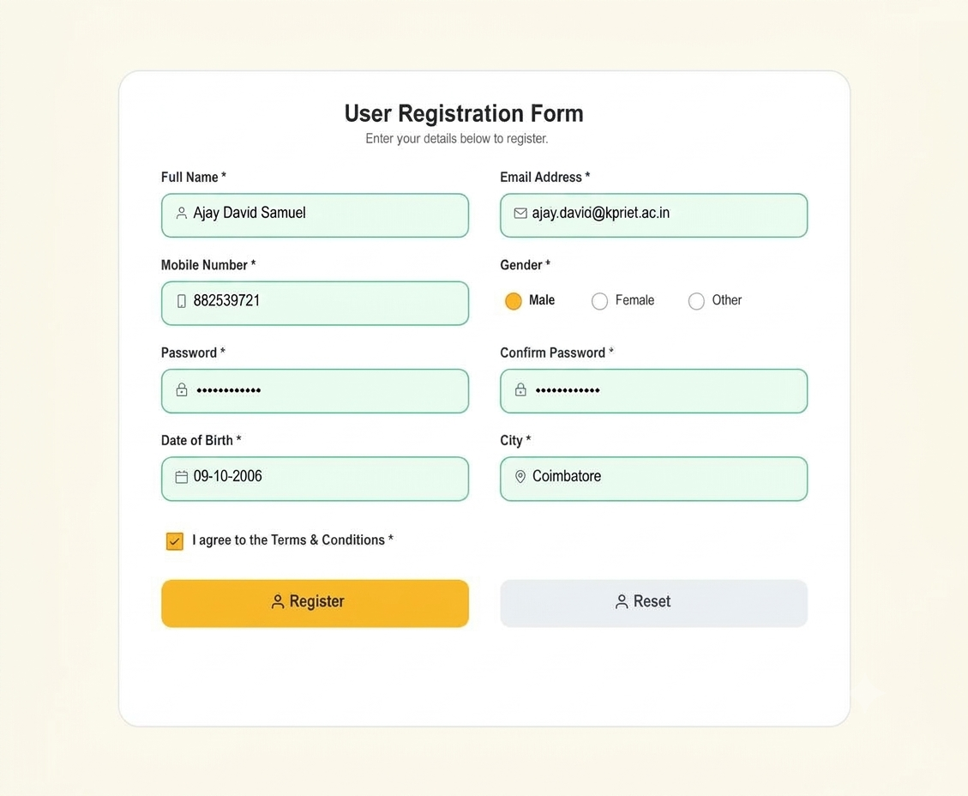

Final Output – Registration Successful :

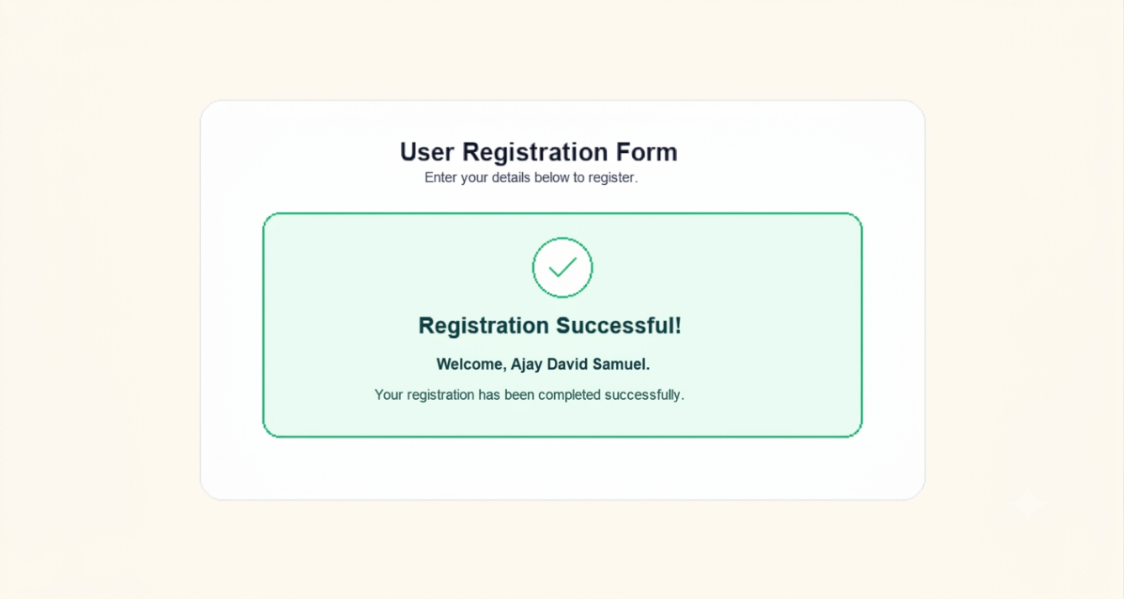

INVALID INPUT:

Invalid Input – No Values Given:

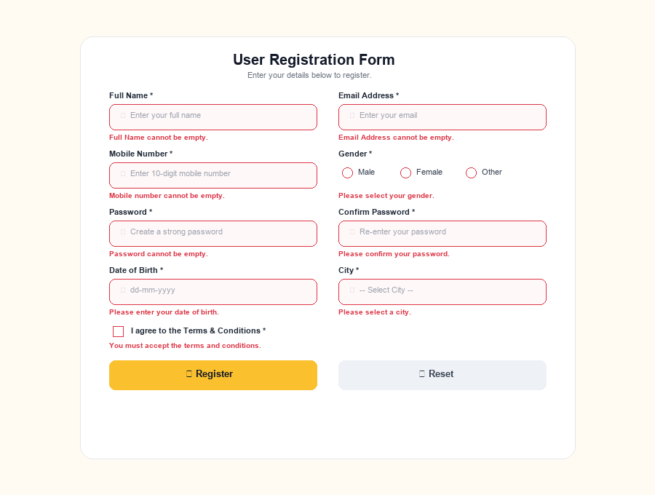

Invalid Input – Invalid Email Address:

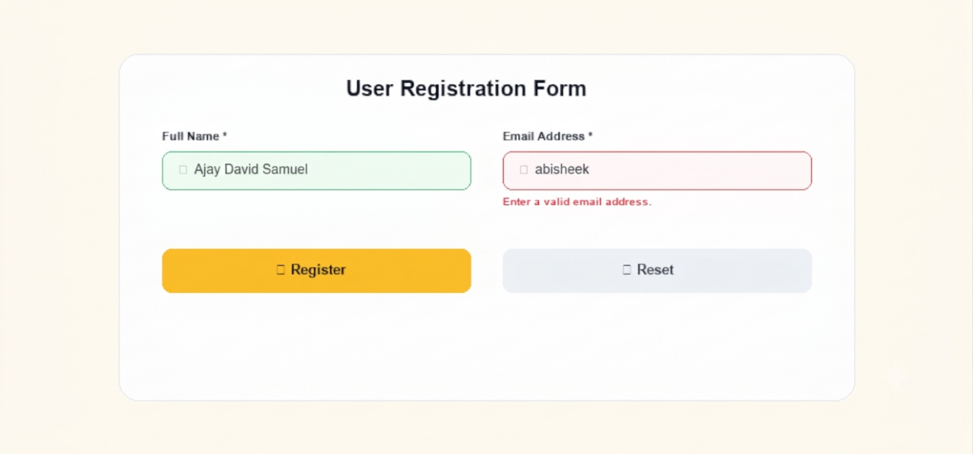

Invalid Input – Invalid Mobile Number & Password:

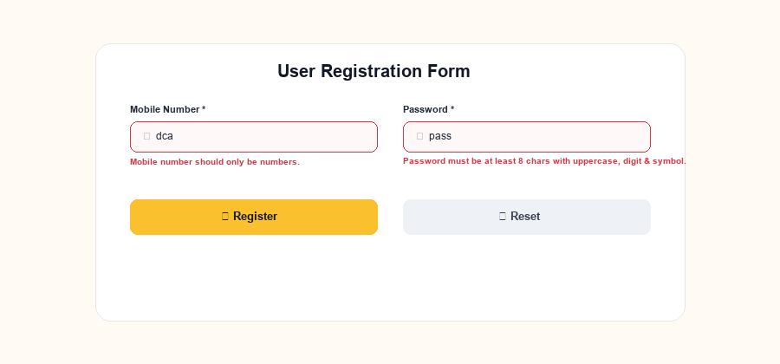

RESULT:
A User Registration Form was successfully designed and developed using HTML, CSS, and JavaScript. The application accepts user registration details, validates the inputs using DOM manipulation and Regular Expressions, displays appropriate validation messages for invalid inputs, prevents invalid form submission, and displays a successful registration message when all the entered details are valid.

Q No: 2 | College admin panel student records and document management using PHP & MySQL

AIM:
To develop a college administration web module using PHP and MySQL that manages student records and their profile documents/images, implementing complete CRUD operations (Add, Edit, Delete, View), file upload handling (size and MIME type validation, unique naming), and metadata storage linked to the relational database.

PROCEDURE:
- Create database college_portal in MySQL with tables students and student_documents.
- Establish secure database connection in db.php using PHP PDO with exception error reporting.
- Design index.php to display student records in a responsive table with photo thumbnails and CRUD action links.
- Develop add_student.php providing input fields for personal details, profile image, and certificate upload.
- Implement server-side file handling in PHP: verify file presence, error code, and size limits (2MB for photo, 5MB for cert).
- Validate MIME types using PHP finfo class to ensure only authentic JPEG, PNG, and PDF files are accepted.
- Generate collision-free unique filenames using uniqid() and timestamps to prevent file overwrites.
- Store uploaded files in the uploads/ directory with restricted execution permissions.
- Execute PDO transactions to insert student information into students and file metadata into student_documents.
- Develop view_student.php to render full student details, photo preview, and an uploaded documents metadata table.
- Develop edit_student.php to modify student details and replace profile photos while removing old files from disk.
- Develop delete_student.php to unlink associated physical files from disk and cascade delete the database record.
- Incorporate flash notifications for success and error states across all CRUD pages.
- Verify all CRUD operations and error handling in a local web browser environment.

HTML & PHP TAGS USED:
<!DOCTYPE
<html>
<head>
<meta>
<title>
<link>
<body>
<div>
<header>
<nav>
<main>
<table>

<thead>
<tbody>
<tr>
<th>
<td>
<form>
<input>
<select>
<button>
<a>
<?php
?>
echo htmlspecialchars() empty()
isset() count()

CSS USED:
background box-sizing color
font-family margin padding text-align
justify-content align-items flex
width
max-width border border-radius
border-collapse box-shadow display
font-size font-weight cursor transition
:hover object-fit

PHP & MYSQL CONSTRUCTS:
new PDO() PDO::ATTR_ERRMODE PDO::ERRMODE_EXCEPTION
prepare() execute() fetchAll()

fetch() lastInsertId() beginTransaction() commit() rollBack()
$_POST
$_FILES UPLOAD_ERR_OK
move_uploaded_file() finfo() FILEINFO_MIME_TYPE
pathinfo() uniqid() time() unlink() file_exists() header() urlencode()
CREATE DATABASE CREATE TABLE INSERT INTO SELECT
UPDATE DELETE JOIN
FOREIGN KEY
ON DELETE CASCADE

schema.sql:
CREATE DATABASE IF NOT EXISTS college_portal;
USE college_portal;

CREATE TABLE IF NOT EXISTS users (
id INT AUTO_INCREMENT PRIMARY KEY,
username VARCHAR(50) NOT NULL UNIQUE,
password VARCHAR(255) NOT NULL,
full_name VARCHAR(100) NOT NULL,
role VARCHAR(20) DEFAULT 'admin',
created_at TIMESTAMP DEFAULT CURRENT_TIMESTAMP
);

CREATE TABLE IF NOT EXISTS students (
id INT AUTO_INCREMENT PRIMARY KEY,
name VARCHAR(100) NOT NULL,
roll_no VARCHAR(30) NOT NULL UNIQUE,
email VARCHAR(100) NOT NULL UNIQUE,
course VARCHAR(100) NOT NULL,
created_at TIMESTAMP DEFAULT CURRENT_TIMESTAMP
);

CREATE TABLE IF NOT EXISTS student_documents (
id INT AUTO_INCREMENT PRIMARY KEY,
student_id INT NOT NULL,
file_name VARCHAR(255) NOT NULL,
file_path VARCHAR(255) NOT NULL,
file_type VARCHAR(100) NOT NULL,
file_size INT NOT NULL,
doc_category VARCHAR(50) NOT NULL,
uploaded_at TIMESTAMP DEFAULT CURRENT_TIMESTAMP,
FOREIGN KEY (student_id) REFERENCES students(id) ON DELETE CASCADE
);

INSERT INTO users (username, password, full_name, role)
VALUES ('admin', 'admin123', 'System Administrator', 'admin')
ON DUPLICATE KEY UPDATE id=id;

INSERT INTO students (name, roll_no, email, course) VALUES
('Ajay David Samuel', '24CS012', 'ajay.david@kpriet.ac.in', 'B.E. Computer Science and Engineering'),
('Meera Nair', '24CS052', 'meera.nair@kpriet.ac.in', 'B.Tech Artificial Intelligence and Data Science'),
('Karthik Raja', '24CS061', 'karthik.r@kpriet.ac.in', 'B.E. Electronics and Communication Engineering')
ON DUPLICATE KEY UPDATE id=id;

db.php:
<?php
$host = 'localhost';
$dbname = 'college_portal';
$username = 'root';
$password = '';

try {
$pdo = new PDO("mysql:host=$host;dbname=$dbname;charset=utf8mb4", $username, $password, [
PDO::ATTR_ERRMODE => PDO::ERRMODE_EXCEPTION,
PDO::ATTR_DEFAULT_FETCH_MODE => PDO::FETCH_ASSOC,
PDO::ATTR_EMULATE_PREPARES => false,
]);
} catch (PDOException $e) {
die("Database Connection Failed: " . htmlspecialchars($e->getMessage()));
}
?>

index.php:

<?php
require_once 'db.php';

$sql = "SELECT s.*, d.file_path AS profile_path
FROM students s
LEFT JOIN student_documents d
ON s.id = d.student_id AND d.doc_category = 'profile_image'
ORDER BY s.id DESC";
$stmt = $pdo->query($sql);
$students = $stmt->fetchAll();
?>
<!DOCTYPE html>
<html lang="en">
<head>
<meta charset="UTF-8">
<title>Admin Dashboard - Student Records</title>
<link rel="stylesheet" href="style.css">
</head>
<body>
<header>
<h1>KPRIET - Admin Portal</h1>
<nav>
<a href="index.php">Students Directory</a>
<a href="add_student.php">+ Add New Student</a>
</nav>
</header>

<main class="container">
<div class="top-bar">
<h2>Student Records Management</h2>
<a href="add_student.php" class="btn btn-success">+ Register New Student</a>
</div>

<?php if (isset($_GET['msg'])): ?>
<div class="alert alert-success"><?= htmlspecialchars($_GET['msg']) ?></div>
<?php endif; ?>
<?php if (isset($_GET['err'])): ?>
<div class="alert alert-error"><?= htmlspecialchars($_GET['err']) ?></div>
<?php endif; ?>

<div class="card">
<h3>Enrolled Students (<?= count($students) ?>)</h3>
<?php if (empty($students)): ?>
<p>No student records found. Click above to add a new record.</p>
<?php else: ?>
<table>
<thead>
<tr>
<th>Photo</th>
<th>Roll No</th>
<th>Full Name</th>
<th>Course / Branch</th>
<th>Email</th>
<th>Actions</th>
</tr>
</thead>
<tbody>
<?php foreach ($students as $student): ?>
<tr>
<td>
<?php if (!empty($student['profile_path']) && file_exists($student['profile_path'])): ?>
<img src="<?= htmlspecialchars($student['profile_path']) ?>" alt="Photo" class="thumbnail">
<?php else: ?>
<div class="thumbnail-placeholder"><?= strtoupper(substr($student['name'], 0, 1)) ?></div>
<?php endif; ?>
</td>
<td><strong><?= htmlspecialchars($student['roll_no']) ?></strong></td>
<td><?= htmlspecialchars($student['name']) ?></td>
<td><span class="badge badge-course"><?= htmlspecialchars($student['course']) ?></span></td>
<td><?= htmlspecialchars($student['email']) ?></td>
<td>
<div class="btn-group">
<a href="view_student.php?id=<?= $student['id'] ?>" class="btn btn-primary">View</a>
<a href="edit_student.php?id=<?= $student['id'] ?>" class="btn btn-warning">Edit</a>
<a href="delete_student.php?id=<?= $student['id'] ?>" class="btn btn-danger"
onclick="return confirm('Are you sure you want to delete student <?= htmlspecialchars($student['name']) ?> and all uploaded files?');">Delete</a>
</div>
</td>
</tr>
<?php endforeach; ?>
</tbody>
</table>
<?php endif; ?>
</div>
</main>

<footer>
<p>&copy; 2026-2027 KPR Institute of Engineering and Technology | Web Technology (U21CS501)</p>
</footer>
</body>
</html>

add_student.php:
<?php

require_once 'db.php';

$errors = [];
$success = "";
$uploadDir = __DIR__ . '/uploads/';

if (!is_dir($uploadDir)) {
mkdir($uploadDir, 0777, true);
}

if ($_SERVER['REQUEST_METHOD'] === 'POST') {
$name = trim($_POST['name'] ?? '');
$roll_no = trim($_POST['roll_no'] ?? '');
$email = trim($_POST['email'] ?? '');
$course = trim($_POST['course'] ?? '');

if (empty($name) || empty($roll_no) || empty($email) || empty($course)) {
$errors[] = "All required text fields must be filled.";
} elseif (!filter_var($email, FILTER_VALIDATE_EMAIL)) {
$errors[] = "Invalid email format.";
}

if (empty($errors)) {
$checkStmt = $pdo->prepare("SELECT id FROM students WHERE roll_no = ? OR email = ?");
$checkStmt->execute([$roll_no, $email]);
if ($checkStmt->fetch()) {
$errors[] = "A student with this Roll Number or Email already exists.";
}
}

function processUpload($fileKey, $category, $allowedTypes, $maxBytes, $uploadDir) {
if (!isset($_FILES[$fileKey]) || $_FILES[$fileKey]['error'] === UPLOAD_ERR_NO_FILE) {
return null;
}

$file = $_FILES[$fileKey];
if ($file['error'] !== UPLOAD_ERR_OK) {
throw new Exception("File upload failed with error code: " . $file['error']);
}

if ($file['size'] > $maxBytes) {
throw new Exception("File for $category exceeds maximum allowed size of " . round($maxBytes / (1024 * 1024)) . " MB.");
}

$finfo = new finfo(FILEINFO_MIME_TYPE);
$mime = $finfo->file($file['tmp_name']);
if (!in_array($mime, $allowedTypes)) {
throw new Exception("Invalid file type ($mime) for $category. Allowed: " . implode(', ', $allowedTypes));
}

$ext = strtolower(pathinfo($file['name'], PATHINFO_EXTENSION));
$uniqueName = $category . '_' . uniqid() . '_' . time() . '.' . $ext;
$destination = $uploadDir . $uniqueName;

if (!move_uploaded_file($file['tmp_name'], $destination)) {
throw new Exception("Failed to move uploaded file to destination directory.");
}

return [
'file_name' => $file['name'],
'file_path' => 'uploads/' . $uniqueName,
'file_type' => $mime,
'file_size' => $file['size'],
'doc_category' => $category
];
}

$uploadedFiles = [];
if (empty($errors)) {
try {

if (isset($_FILES['profile_image']) && $_FILES['profile_image']['error'] !== UPLOAD_ERR_NO_FILE) {
$photo = processUpload('profile_image', 'profile_image', ['image/jpeg', 'image/png'], 2 * 1024 * 1024, $uploadDir);
if ($photo) $uploadedFiles[] = $photo;
}

if (isset($_FILES['document']) && $_FILES['document']['error'] !== UPLOAD_ERR_NO_FILE) {
$doc = processUpload('document', 'certificate', ['application/pdf', 'image/jpeg', 'image/png'], 5 * 1024 * 1024, $uploadDir);
if ($doc) $uploadedFiles[] = $doc;
}
} catch (Exception $e) {
$errors[] = $e->getMessage();
}
}

if (empty($errors)) {
try {
$pdo->beginTransaction();

$insertStudent = $pdo->prepare("INSERT INTO students (name, roll_no, email, course) VALUES (?, ?, ?, ?)");
$insertStudent->execute([$name, $roll_no, $email, $course]);
$studentId = $pdo->lastInsertId();

$insertDoc = $pdo->prepare("INSERT INTO student_documents (student_id, file_name, file_path, file_type, file_size, doc_category) VALUES (?, ?, ?, ?, ?, ?)");
foreach ($uploadedFiles as $docMeta) {
$insertDoc->execute([
$studentId,
$docMeta['file_name'],
$docMeta['file_path'],
$docMeta['file_type'],
$docMeta['file_size'],
$docMeta['doc_category']
]);
}

$pdo->commit();
header("Location: index.php?msg=" . urlencode("Student registered successfully with documents!"));
exit;
} catch (PDOException $e) {
$pdo->rollBack();
$errors[] = "Database Error: " . $e->getMessage();
}
}
}
?>
<!DOCTYPE html>
<html lang="en">
<head>
<meta charset="UTF-8">
<title>Add Student Record - Admin Portal</title>
<link rel="stylesheet" href="style.css">
</head>
<body>
<header>
<h1>KPRIET - Admin Portal</h1>
<nav>
<a href="index.php">&larr; Back to Directory</a>
</nav>
</header>

<main class="container">
<div class="card">
<h3>Register New Student &amp; Upload Credentials</h3>

<?php if (!empty($errors)): ?>
<div class="alert alert-error">
<ul>
<?php foreach ($errors as $err): ?>
<li><?= htmlspecialchars($err) ?></li>
<?php endforeach; ?>
</ul>
</div>
<?php endif; ?>

<form action="add_student.php" method="POST" enctype="multipart/form-data">
<div class="form-group">
<label for="name">Student Full Name *</label>
<input type="text" name="name" id="name" required
value="<?= htmlspecialchars($_POST['name'] ?? '') ?>" placeholder="e.g. Ajay David Samuel">
</div>

<div class="form-group">
<label for="roll_no">Roll Number *</label>
<input type="text" name="roll_no" id="roll_no" required
value="<?= htmlspecialchars($_POST['roll_no'] ?? '') ?>" placeholder="e.g. 24CS012">
</div>

<div class="form-group">
<label for="email">Institutional Email Address *</label>
<input type="email" name="email" id="email" required
value="<?= htmlspecialchars($_POST['email'] ?? '') ?>" placeholder="e.g. ajay.david@kpriet.ac.in">
</div>

<div class="form-group">
<label for="course">Course / Department *</label>
<select name="course" id="course" required>
<option value="">-- Select Degree &amp; Branch --</option>
<option value="B.E. Computer Science and Engineering">B.E. Computer Science and Engineering</option>
<option value="B.Tech Artificial Intelligence and Data Science">B.Tech Artificial Intelligence and Data Science</option>
<option value="B.E. Electronics and Communication Engineering">B.E. Electronics and Communication Engineering</option>
<option value="B.Tech Information Technology">B.Tech Information Technology</option>
</select>
</div>

<div class="form-group">
<label for="profile_image">Profile Photograph (JPG/PNG, Max 2MB)</label>
<input type="file" name="profile_image" id="profile_image" accept="image/jpeg,image/png">
</div>

<div class="form-group">
<label for="document">ID Proof / Certificate (PDF/JPG/PNG, Max 5MB)</label>
<input type="file" name="document" id="document" accept="application/pdf,image/jpeg,image/png">
</div>

<div style="margin-top: 25px;">
<button type="submit" class="btn btn-success">Save Student Record</button>
<a href="index.php" class="btn btn-secondary">Cancel</a>
</div>
</form>
</div>
</main>

<footer>
<p>&copy; 2026-2027 KPR Institute of Engineering and Technology | Web Technology (U21CS501)</p>
</footer>
</body>
</html>
```

view_student.php:
<?php

require_once 'db.php';

$studentId = $_GET['id'] ?? null;
if (!$studentId || !is_numeric($studentId)) {
header("Location: index.php?err=" . urlencode("Invalid Student ID"));
exit;
}

$stmt = $pdo->prepare("SELECT * FROM students WHERE id = ?");
$stmt->execute([$studentId]);
$student = $stmt->fetch();

if (!$student) {
header("Location: index.php?err=" . urlencode("Student record not found."));
exit;
}

$docStmt = $pdo->prepare("SELECT * FROM student_documents WHERE student_id = ? ORDER BY uploaded_at DESC");
$docStmt->execute([$studentId]);
$documents = $docStmt->fetchAll();

$profileImage = null;
foreach ($documents as $doc) {
if ($doc['doc_category'] === 'profile_image' && file_exists($doc['file_path'])) {
$profileImage = $doc['file_path'];
break;
}
}
?>
<!DOCTYPE html>
<html lang="en">
<head>
<meta charset="UTF-8">
<title>View Student Details - <?= htmlspecialchars($student['name']) ?></title>
<link rel="stylesheet" href="style.css">
</head>
<body>
<header>
<h1>KPRIET - Admin Portal</h1>
<nav>
<a href="index.php">&larr; Back to Directory</a>
<a href="edit_student.php?id=<?= $student['id'] ?>">Edit Record</a>
</nav>
</header>

<main class="container">
<div class="top-bar">
<h2>Student Profile Overview</h2>
<div>
<a href="edit_student.php?id=<?= $student['id'] ?>" class="btn btn-warning">Edit Profile</a>
<a href="delete_student.php?id=<?= $student['id'] ?>" class="btn btn-danger"
onclick="return confirm('Delete this student and associated documents?');">Delete</a>
</div>
</div>

<!-- Student Details Card -->
<div class="card">
<div class="profile-card">
<div>
<?php if ($profileImage): ?>
<img src="<?= htmlspecialchars($profileImage) ?>" alt="Student Photo" class="profile-large">
<?php else: ?>
<div class="profile-large" style="background:#e2e8f0; display:flex; align-items:center; justify-content:center; font-size:40px; color:#64748b;">
<?= strtoupper(substr($student['name'], 0, 1)) ?>
</div>
<?php endif; ?>
</div>
<div class="profile-details">
<h3><?= htmlspecialchars($student['name']) ?></h3>
<p><strong>Roll Number:</strong> <?= htmlspecialchars($student['roll_no']) ?></p>
<p><strong>Email:</strong> <?= htmlspecialchars($student['email']) ?></p>
<p><strong>Enrolled Course:</strong> <span class="badge badge-course"><?= htmlspecialchars($student['course']) ?></span></p>
<p><strong>Registered Date:</strong> <?= date('d M Y, h:i A', strtotime($student['created_at'])) ?></p>
</div>
</div>
</div>

<!-- Uploaded Documents & Metadata Table -->
<div class="card">
<h3>Uploaded Documents &amp; Metadata (<?= count($documents) ?>)</h3>
<?php if (empty($documents)): ?>
<p>No documents uploaded for this student.</p>
<?php else: ?>
<table>
<thead>
<tr>
<th>Category</th>
<th>Original File Name</th>
<th>MIME Type</th>
<th>Size</th>
<th>Uploaded At</th>
<th>Action</th>
</tr>
</thead>
<tbody>
<?php foreach ($documents as $doc): ?>
<tr>
<td><span class="badge badge-doc"><?= htmlspecialchars(ucwords(str_replace('_', ' ', $doc['doc_category']))) ?></span></td>
<td><?= htmlspecialchars($doc['file_name']) ?></td>
<td><code><?= htmlspecialchars($doc['file_type']) ?></code></td>
<td><?= round($doc['file_size'] / 1024, 1) ?> KB</td>
<td><?= date('d-m-Y H:i', strtotime($doc['uploaded_at'])) ?></td>
<td>
<a href="<?= htmlspecialchars($doc['file_path']) ?>" target="_blank" class="btn btn-primary" download>Download / View</a>
</td>
</tr>
<?php endforeach; ?>
</tbody>
</table>
<?php endif; ?>
</div>
</main>

<footer>
<p>&copy; 2026-2027 KPR Institute of Engineering and Technology | Web Technology (U21CS501)</p>
</footer>
</body>
</html>
```

edit_student.php:
<?php

require_once 'db.php';

$studentId = $_GET['id'] ?? null;
if (!$studentId || !is_numeric($studentId)) {
header("Location: index.php?err=" . urlencode("Invalid Student ID"));
exit;
}

$stmt = $pdo->prepare("SELECT * FROM students WHERE id = ?");
$stmt->execute([$studentId]);
$student = $stmt->fetch();

if (!$student) {
header("Location: index.php?err=" . urlencode("Student record not found."));
exit;

$errors = [];
$uploadDir = __DIR__ . '/uploads/';

if ($_SERVER['REQUEST_METHOD'] === 'POST') {
$name = trim($_POST['name'] ?? '');
$roll_no = trim($_POST['roll_no'] ?? '');
$email = trim($_POST['email'] ?? '');
$course = trim($_POST['course'] ?? '');

if (empty($name) || empty($roll_no) || empty($email) || empty($course)) {
$errors[] = "All required fields must be filled.";
} elseif (!filter_var($email, FILTER_VALIDATE_EMAIL)) {
$errors[] = "Invalid email format.";
}

if (empty($errors)) {
$checkStmt = $pdo->prepare("SELECT id FROM students WHERE (roll_no = ? OR email = ?) AND id != ?");
$checkStmt->execute([$roll_no, $email, $studentId]);
if ($checkStmt->fetch()) {
$errors[] = "Roll number or email is already registered by another student.";
}
}

if (empty($errors) && isset($_FILES['profile_image']) && $_FILES['profile_image']['error'] !== UPLOAD_ERR_NO_FILE) {
$file = $_FILES['profile_image'];
if ($file['size'] > 2 * 1024 * 1024) {
$errors[] = "Profile photo exceeds 2 MB limit.";
} else {
$finfo = new finfo(FILEINFO_MIME_TYPE);
$mime = $finfo->file($file['tmp_name']);
if (!in_array($mime, ['image/jpeg', 'image/png'])) {
$errors[] = "Only JPG and PNG images are allowed for profile photo.";
} else {

$oldDocStmt = $pdo->prepare("SELECT id, file_path FROM student_documents WHERE student_id = ? AND doc_category = 'profile_image'");
$oldDocStmt->execute([$studentId]);
$oldDoc = $oldDocStmt->fetch();
if ($oldDoc && file_exists($oldDoc['file_path'])) {
@unlink($oldDoc['file_path']);
}

$ext = strtolower(pathinfo($file['name'], PATHINFO_EXTENSION));
$uniqueName = 'profile_' . uniqid() . '_' . time() . '.' . $ext;
$dest = $uploadDir . $uniqueName;

if (move_uploaded_file($file['tmp_name'], $dest)) {
if ($oldDoc) {
$updateDoc = $pdo->prepare("UPDATE student_documents SET file_name=?, file_path=?, file_type=?, file_size=?, uploaded_at=CURRENT_TIMESTAMP WHERE id=?");
$updateDoc->execute([$file['name'], 'uploads/' . $uniqueName, $mime, $file['size'], $oldDoc['id']]);
} else {
$insertDoc = $pdo->prepare("INSERT INTO student_documents (student_id, file_name, file_path, file_type, file_size, doc_category) VALUES (?, ?, ?, ?, ?, 'profile_image')");
$insertDoc->execute([$studentId, $file['name'], 'uploads/' . $uniqueName, $mime, $file['size']]);
}
}
}
}
}

if (empty($errors)) {
try {
$updateStmt = $pdo->prepare("UPDATE students SET name = ?, roll_no = ?, email = ?, course = ? WHERE id = ?");
$updateStmt->execute([$name, $roll_no, $email, $course, $studentId]);
header("Location: view_student.php?id=$studentId&msg=" . urlencode("Student details updated successfully!"));
exit;
} catch (PDOException $e) {
$errors[] = "Database update error: " . $e->getMessage();
}
}
}
?>
<!DOCTYPE html>
<html lang="en">
<head>
<meta charset="UTF-8">
<title>Edit Student - <?= htmlspecialchars($student['name']) ?></title>
<link rel="stylesheet" href="style.css">
</head>
<body>
<header>
<h1>KPRIET - Admin Portal</h1>
<nav>
<a href="index.php">&larr; Back to Directory</a>
<a href="view_student.php?id=<?= $student['id'] ?>">View Profile</a>
</nav>
</header>

<main class="container">
<div class="card">
<h3>Edit Student Information</h3>

<?php if (!empty($errors)): ?>
<div class="alert alert-error">
<ul>
<?php foreach ($errors as $err): ?>
<li><?= htmlspecialchars($err) ?></li>
<?php endforeach; ?>
</ul>
</div>
<?php endif; ?>

<form action="edit_student.php?id=<?= $student['id'] ?>" method="POST" enctype="multipart/form-data">
<div class="form-group">
<label for="name">Student Full Name *</label>
<input type="text" name="name" id="name" required value="<?= htmlspecialchars($student['name']) ?>">
</div>

<div class="form-group">
<label for="roll_no">Roll Number *</label>
<input type="text" name="roll_no" id="roll_no" required value="<?= htmlspecialchars($student['roll_no']) ?>">
</div>

<div class="form-group">
<label for="email">Institutional Email *</label>
<input type="email" name="email" id="email" required value="<?= htmlspecialchars($student['email']) ?>">
</div>

<div class="form-group">
<label for="course">Course / Department *</label>
<select name="course" id="course" required>
<?php
$courses = [
"B.E. Computer Science and Engineering",
"B.Tech Artificial Intelligence and Data Science",
"B.E. Electronics and Communication Engineering",
"B.Tech Information Technology",
"B.E. Mechanical Engineering"
];
foreach ($courses as $c):
?>
<option value="<?= $c ?>" <?= ($student['course'] === $c) ? 'selected' : '' ?>><?= $c ?></option>
<?php endforeach; ?>
</select>
</div>

<div class="form-group">
<label for="profile_image">Update Profile Photograph (Optional, JPG/PNG)</label>
<input type="file" name="profile_image" id="profile_image" accept="image/jpeg,image/png">
</div>

<div style="margin-top: 25px;">
<button type="submit" class="btn btn-warning">Update Changes</button>
<a href="view_student.php?id=<?= $student['id'] ?>" class="btn btn-secondary">Cancel</a>
</div>
</form>
</div>
</main>

<footer>
<p>&copy; 2026-2027 KPR Institute of Engineering and Technology | Web Technology (U21CS501)</p>
</footer>
</body>
</html>
```

delete_student.php:
<?php

require_once 'db.php';

$studentId = $_GET['id'] ?? null;
if (!$studentId || !is_numeric($studentId)) {
header("Location: index.php?err=" . urlencode("Invalid Student ID"));
exit;
}

try {
// 1. Locate and unlink physical files from storage
$fileStmt = $pdo->prepare("SELECT file_path FROM student_documents WHERE student_id = ?");
$fileStmt->execute([$studentId]);
$files = $fileStmt->fetchAll();

foreach ($files as $file) {
$fullPath = __DIR__ . '/' . $file['file_path'];
if (file_exists($fullPath) && is_file($fullPath)) {
@unlink($fullPath);
}
}

// 2. Cascade delete will clean up student_documents automatically in MySQL
$delStmt = $pdo->prepare("DELETE FROM students WHERE id = ?");
$delStmt->execute([$studentId]);

header("Location: index.php?msg=" . urlencode("Student record and associated files successfully deleted."));
exit;
} catch (PDOException $e) {
header("Location: index.php?err=" . urlencode("Failed to delete student: " . $e->getMessage()));
exit;
}
?>

style.css:
* {
box-sizing: border-box;
margin: 0;
padding: 0;
}

body {
font-family: 'Segoe UI', Arial, sans-serif;
background-color: #f4f6fa;
color: #2c3e50;
line-height: 1.6;
}

header {
background-color: #1b2a4a;
color: white;
padding: 18px 6%;
display: flex;
justify-content: space-between;
align-items: center;
border-bottom: 4px solid #c0392b;
}

header h1 {
font-size: 22px;
}

header nav a {
color: #ecf0f1;
text-decoration: none;
font-weight: 600;
margin-left: 20px;
font-size: 14px;
}

header nav a:hover {
color: #e74c3c;
}

.container {
width: 92%;
max-width: 1100px;
margin: 30px auto;
}

.top-bar {
display: flex;
justify-content: space-between;
align-items: center;
margin-bottom: 20px;
flex-wrap: wrap;
gap: 15px;
}

.top-bar h2 {
color: #1b2a4a;
}

.card {
background: white;
border-radius: 8px;
padding: 25px;
border: 1px solid #e2e8f0;
box-shadow: 0 4px 15px rgba(0, 0, 0, 0.05);
margin-bottom: 25px;
}

.card h3 {
color: #1b2a4a;
border-left: 4px solid #c0392b;
padding-left: 10px;
margin-bottom: 18px;
}

table {
width: 100%;
border-collapse: collapse;
margin-top: 10px;
}

th, td {
padding: 12px 14px;
text-align: left;
border-bottom: 1px solid #e2e8f0;
}

th {
background-color: #1b2a4a;
color: white;
font-size: 14px;
}

tr:hover {
background-color: #f8fafc;
}

.thumbnail {
width: 48px;
height: 48px;
border-radius: 50%;
object-fit: cover;
border: 2px solid #cbd5e1;
}

.thumbnail-placeholder {
width: 48px;
height: 48px;
border-radius: 50%;
background-color: #e2e8f0;
display: flex;
align-items: center;
justify-content: center;
font-weight: bold;
color: #64748b;
font-size: 14px;
}

.btn {
display: inline-block;
padding: 8px 16px;
font-size: 13px;
font-weight: 600;
border-radius: 4px;
text-decoration: none;
cursor: pointer;
border: none;
transition: all 0.2s;
}

.btn-primary { background: #1b2a4a; color: white; }
.btn-primary:hover { background: #0f1a30; }
.btn-success { background: #27ae60; color: white; }
.btn-success:hover { background: #1e8449; }
.btn-warning { background: #f39c12; color: white; }
.btn-warning:hover { background: #d68910; }
.btn-danger { background: #e74c3c; color: white; }
.btn-danger:hover { background: #c0392b; }
.btn-secondary { background: #7f8c8d; color: white; }
.btn-secondary:hover { background: #626567; }
.btn-group { display: flex; gap: 8px; }

.badge {
display: inline-block;
padding: 4px 8px;
border-radius: 4px;
font-size: 11px;
font-weight: bold;
}

.badge-course { background: #e0f2fe; color: #0369a1; }
.badge-doc { background: #fef3c7; color: #92400e; }

.alert {
padding: 12px 18px;
border-radius: 6px;
margin-bottom: 20px;
font-size: 14px;
font-weight: 500;
}

.alert-success { background: #def7ec; color: #03543f; border: 1px solid #84e1bc; }
.alert-error { background: #fde8e8; color: #9b1c1c; border: 1px solid #f8b4b4; }

.form-group {
margin-bottom: 16px;
}

.form-group label {
display: block;
font-weight: 600;
font-size: 14px;
margin-bottom: 6px;
color: #334155;
}

.form-group input,
.form-group select {
width: 100%;
padding: 10px 12px;
border: 1px solid #cbd5e1;
border-radius: 5px;
font-size: 14px;
}

.form-group input:focus,
.form-group select:focus {
outline: none;
border-color: #1b2a4a;
}

.profile-card {
display: flex;
gap: 30px;
align-items: flex-start;
}

.profile-large {
width: 140px;
height: 140px;
border-radius: 8px;
object-fit: cover;
border: 3px solid #1b2a4a;
}

.profile-details {
flex: 1;
}

.profile-details p {
margin-bottom: 8px;
font-size: 15px;
}

.profile-details strong {
color: #1b2a4a;
min-width: 120px;
display: inline-block;
}

footer {
text-align: center;
padding: 18px;
color: #64748b;
font-size: 13px;
margin-top: 40px;
}

OUTPUT :

VALID OPERATIONS :

Valid Operation – Student Records Directory (CRUD Read) :

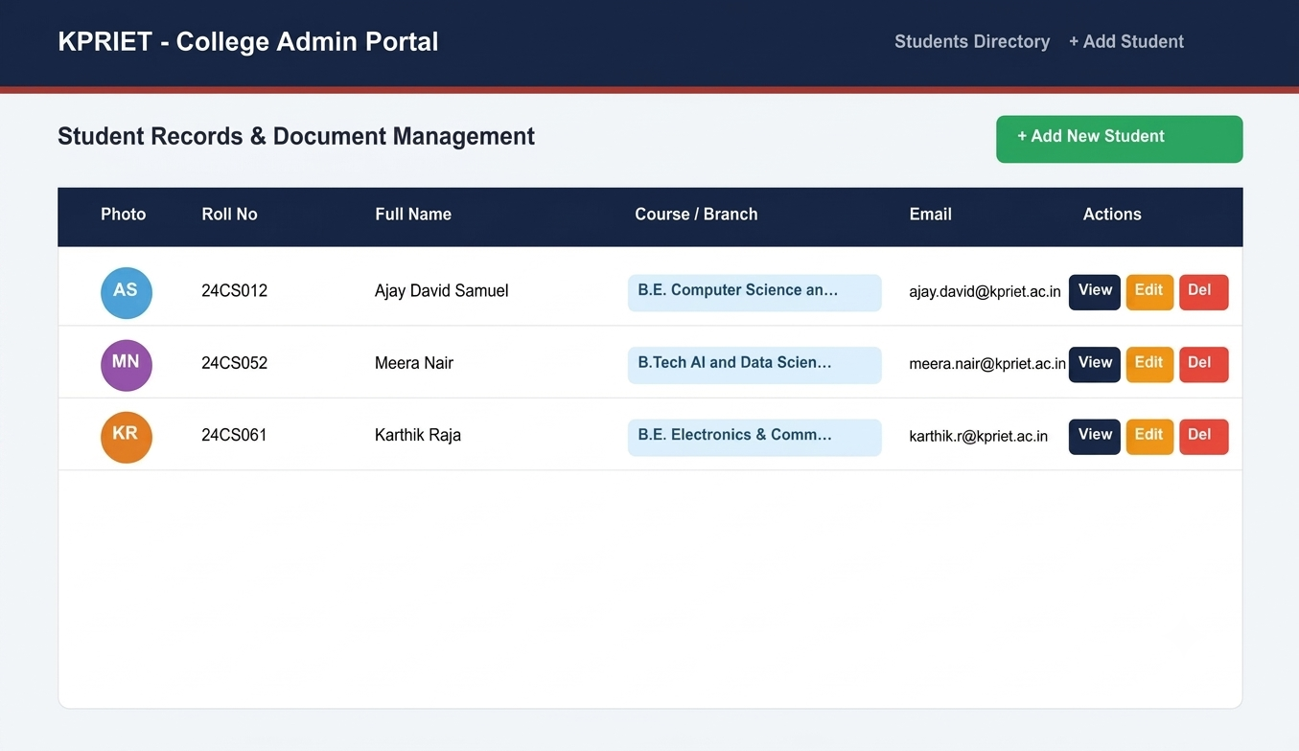

Valid Operation – View Student Profile with Uploaded Documents and Metadata :

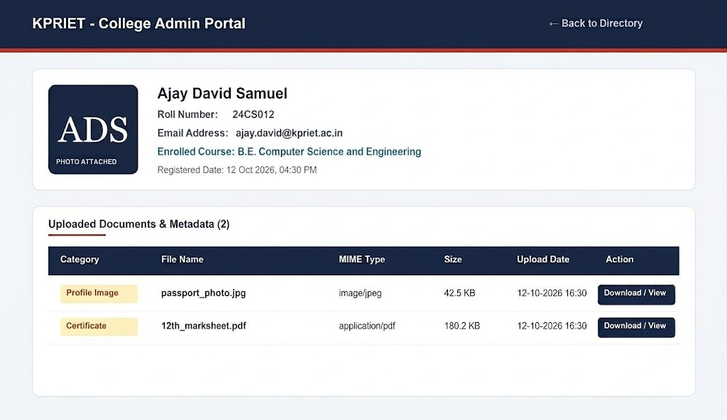

RESULT:
A College Admin Panel for managing student records and profile documents was successfully developed using PHP and MySQL. The system performs complete CRUD operations, enforces file size and MIME type validations, stores comprehensive document metadata in MySQL, safely handles server-side uploads without overwriting, and securely deletes physical files upon record removal.

Q No: 3 | Dynamic student profiles portal with image & document streaming using Java Servlets, JDBC & JSP

AIM:
To develop a Java Web Application using Servlets, JDBC, and JSP to display verified student profiles dynamically, retrieve and byte-stream images and documents from server storage using <img> tags pointing to the Servlet, implement looping and conditional logic for multiple students, and enforce secure session handling.

PROCEDURE:
- Configure web.xml deployment descriptor with servlet declarations and mappings for LoginServlet, LogoutServlet, StudentListServlet, and StreamDocumentServlet.
- Set session-timeout to 30 minutes in web.xml.
- Create DBConnection.java to load MySQL JDBC Driver (com.mysql.cj.jdbc.Driver) and supply database connections.
- Implement LoginServlet to authenticate administrator credentials against the users table in MySQL.
- Create an HttpSession upon successful authentication and store user credentials in session attributes.
- Implement LogoutServlet to invalidate the user session and redirect to login.jsp.
- Develop StudentListServlet to verify session authentication, execute JDBC queries joining students and student_documents, and forward data to students.jsp.
- Develop StreamDocumentServlet to fetch file metadata from MySQL, locate physical files on disk, set Content-Type and Content-Disposition headers, and stream binary data via OutputStream.
- Design login.jsp providing a responsive administrative login card with credential verification.
- Design dynamic students.jsp incorporating session checks to block unauthorized access.
- Use JSP scriptlet looping (<% for (...) %>) to render multiple student profile cards dynamically.
- Use <img> tags with src pointing to StreamDocumentServlet?id=... to render streamed profile photos.
- Implement conditional logic to display document download buttons when documents exist or a fallback indicator when absent.
- Test secure authenticated browsing, image streaming, document download, and session invalidation.

SERVLET & JSP CONSTRUCTS USED:
web.xml
<servlet>
<servlet-mapping>
<session-config>
<welcome-file-list> HttpServlet doGet()
doPost() HttpServletRequest HttpServletResponse HttpSession request.getSession() session.setAttribute() session.getAttribute()

session.invalidate() RequestDispatcher dispatcher.forward() response.sendRedirect() response.setContentType() response.setContentLengthLong() response.setHeader() response.getOutputStream() FileInputStream
File
<%@ page %>
<% %>
<%= %>

JDBC CONSTRUCTS USED:
Class.forName("com.mysql.cj.jdbc.Driver") DriverManager.getConnection() Connection
PreparedStatement ResultSet executeQuery() prepareStatement() conn.close() stmt.close() rs.close() SQLException

web.xml:
<?xml version="1.0" encoding="UTF-8"?>
<web-app xmlns="http://xmlns.jcp.org/xml/ns/javaee"
xmlns:xsi="http://www.w3.org/2001/XMLSchema-instance"
xsi:schemaLocation="http://xmlns.jcp.org/xml/ns/javaee
http://xmlns.jcp.org/xml/ns/javaee/web-app_3_1.xsd"
version="3.1">

<display-name>KPRIET Student Portal - Servlets</display-name>

<welcome-file-list>
<welcome-file>login.jsp</welcome-file>
</welcome-file-list>

<servlet>
<servlet-name>LoginServlet</servlet-name>
<servlet-class>LoginServlet</servlet-class>
</servlet>
<servlet-mapping>
<servlet-name>LoginServlet</servlet-name>
<url-pattern>/login</url-pattern>
</servlet-mapping>

<servlet>
<servlet-name>LogoutServlet</servlet-name>
<servlet-class>LogoutServlet</servlet-class>
</servlet>
<servlet-mapping>
<servlet-name>LogoutServlet</servlet-name>
<url-pattern>/logout</url-pattern>
</servlet-mapping>

<servlet>
<servlet-name>StudentListServlet</servlet-name>
<servlet-class>StudentListServlet</servlet-class>
</servlet>
<servlet-mapping>
<servlet-name>StudentListServlet</servlet-name>
<url-pattern>/students</url-pattern>
</servlet-mapping>

<servlet>
<servlet-name>StreamDocumentServlet</servlet-name>
<servlet-class>StreamDocumentServlet</servlet-class>
</servlet>
<servlet-mapping>
<servlet-name>StreamDocumentServlet</servlet-name>
<url-pattern>/streamDocument</url-pattern>
</servlet-mapping>

<session-config>
<session-timeout>30</session-timeout>
</session-config>
</web-app>

DBConnection.java:
import java.sql.Connection;
import java.sql.DriverManager;
import java.sql.SQLException;

public class DBConnection {
private static final String URL = "jdbc:mysql://localhost:3306/college_portal?useSSL=false&allowPublicKeyRetrieval=true&serverTimezone=UTC";
private static final String USER = "root";
private static final String PASSWORD = ""; // Adjust to match local MySQL credentials

static {
try {
Class.forName("com.mysql.cj.jdbc.Driver");
} catch (ClassNotFoundException e) {
System.err.println("MySQL JDBC Driver not found in classpath: " + e.getMessage());
}
}

public static Connection getConnection() throws SQLException {
return DriverManager.getConnection(URL, USER, PASSWORD);
}
}

LoginServlet.java:
import java.io.IOException;
import java.sql.Connection;
import java.sql.PreparedStatement;
import java.sql.ResultSet;
import javax.servlet.ServletException;
import javax.servlet.http.HttpServlet;
import javax.servlet.http.HttpServletRequest;
import javax.servlet.http.HttpServletResponse;
import javax.servlet.http.HttpSession;

public class LoginServlet extends HttpServlet {
@Override
protected void doPost(HttpServletRequest request, HttpServletResponse response)
throws ServletException, IOException {

String username = request.getParameter("username");
String password = request.getParameter("password");

if (username == null || password == null || username.trim().isEmpty() || password.trim().isEmpty()) {
response.sendRedirect("login.jsp?error=Please+enter+both+username+and+password");
return;
}

Connection conn = null;
PreparedStatement stmt = null;
ResultSet rs = null;

try {
conn = DBConnection.getConnection();
String sql = "SELECT * FROM users WHERE username = ? AND password = ?";
stmt = conn.prepareStatement(sql);
stmt.setString(1, username.trim());
stmt.setString(2, password.trim());
rs = stmt.executeQuery();

if (rs.next()) {
HttpSession session = request.getSession(true);
session.setAttribute("user", rs.getString("username"));
session.setAttribute("fullName", rs.getString("full_name"));
session.setAttribute("role", rs.getString("role"));
response.sendRedirect("students");
} else {
response.sendRedirect("login.jsp?error=Invalid+username+or+password");
}
} catch (Exception e) {
e.printStackTrace();
response.sendRedirect("login.jsp?error=Database+error:+" + e.getMessage());
} finally {
try { if (rs != null) rs.close(); } catch (Exception ignored) {}
try { if (stmt != null) stmt.close(); } catch (Exception ignored) {}
try { if (conn != null) conn.close(); } catch (Exception ignored) {}
}
}

@Override
protected void doGet(HttpServletRequest request, HttpServletResponse response)
throws ServletException, IOException {
response.sendRedirect("login.jsp");
}
}

LogoutServlet.java:
import java.io.IOException;
import javax.servlet.ServletException;
import javax.servlet.http.HttpServlet;
import javax.servlet.http.HttpServletRequest;
import javax.servlet.http.HttpServletResponse;
import javax.servlet.http.HttpSession;

public class LogoutServlet extends HttpServlet {
@Override
protected void doGet(HttpServletRequest request, HttpServletResponse response)
throws ServletException, IOException {

HttpSession session = request.getSession(false);
if (session != null) {
session.removeAttribute("user");
session.removeAttribute("fullName");
session.invalidate();
}
response.sendRedirect("login.jsp?msg=You+have+been+logged+out+securely.");
}
}

StudentListServlet.java:
import java.io.IOException;
import java.sql.Connection;
import java.sql.PreparedStatement;
import java.sql.ResultSet;
import java.util.ArrayList;
import java.util.HashMap;
import java.util.List;
import java.util.Map;
import javax.servlet.RequestDispatcher;
import javax.servlet.ServletException;
import javax.servlet.http.HttpServlet;
import javax.servlet.http.HttpServletRequest;
import javax.servlet.http.HttpServletResponse;
import javax.servlet.http.HttpSession;

public class StudentListServlet extends HttpServlet {
@Override
protected void doGet(HttpServletRequest request, HttpServletResponse response)
throws ServletException, IOException {

HttpSession session = request.getSession(false);
if (session == null || session.getAttribute("user") == null) {
response.sendRedirect("login.jsp?error=Access+denied.+Please+login+first.");
return;
}

List<Map<String, Object>> studentList = new ArrayList<>();
Connection conn = null;
PreparedStatement stmt = null;
ResultSet rs = null;

try {
conn = DBConnection.getConnection();
String sql = "SELECT s.id AS student_id, s.name, s.roll_no, s.email, s.course, s.created_at, " +
" d1.id AS photo_doc_id, d1.file_name AS photo_name, " +
" d2.id AS cert_doc_id, d2.file_name AS cert_name, d2.file_type AS cert_type " +
"FROM students s " +
"LEFT JOIN student_documents d1 ON s.id = d1.student_id AND d1.doc_category = 'profile_image' " +
"LEFT JOIN student_documents d2 ON s.id = d2.student_id AND d2.doc_category != 'profile_image' " +
"ORDER BY s.id DESC";

stmt = conn.prepareStatement(sql);
rs = stmt.executeQuery();

while (rs.next()) {
Map<String, Object> map = new HashMap<>();
map.put("student_id", rs.getInt("student_id"));
map.put("name", rs.getString("name"));
map.put("roll_no", rs.getString("roll_no"));
map.put("email", rs.getString("email"));
map.put("course", rs.getString("course"));
map.put("created_at", rs.getString("created_at"));

map.put("photo_doc_id", rs.getObject("photo_doc_id"));
map.put("photo_name", rs.getString("photo_name"));
map.put("cert_doc_id", rs.getObject("cert_doc_id"));
map.put("cert_name", rs.getString("cert_name"));
map.put("cert_type", rs.getString("cert_type"));

studentList.add(map);
}

request.setAttribute("studentList", studentList);
RequestDispatcher dispatcher = request.getRequestDispatcher("students.jsp");
dispatcher.forward(request, response);

} catch (Exception e) {
e.printStackTrace();
request.setAttribute("errorMessage", "Database retrieval error: " + e.getMessage());
RequestDispatcher dispatcher = request.getRequestDispatcher("students.jsp");
dispatcher.forward(request, response);
} finally {
try { if (rs != null) rs.close(); } catch (Exception ignored) {}
try { if (stmt != null) stmt.close(); } catch (Exception ignored) {}
try { if (conn != null) conn.close(); } catch (Exception ignored) {}
}
}
}

StreamDocumentServlet.java:
import java.io.File;
import java.io.FileInputStream;
import java.io.IOException;
import java.io.OutputStream;
import java.sql.Connection;
import java.sql.PreparedStatement;
import java.sql.ResultSet;
import javax.servlet.ServletException;
import javax.servlet.http.HttpServlet;
import javax.servlet.http.HttpServletRequest;
import javax.servlet.http.HttpServletResponse;
import javax.servlet.http.HttpSession;

public class StreamDocumentServlet extends HttpServlet {
private static final int BUFFER_SIZE = 8192;

@Override
protected void doGet(HttpServletRequest request, HttpServletResponse response)
throws ServletException, IOException {

HttpSession session = request.getSession(false);
if (session == null || session.getAttribute("user") == null) {
response.sendError(HttpServletResponse.SC_UNAUTHORIZED, "Access Denied: Please log in.");
return;
}

String docIdStr = request.getParameter("id");
if (docIdStr == null || docIdStr.trim().isEmpty()) {
response.sendError(HttpServletResponse.SC_BAD_REQUEST, "Document ID parameter is missing.");
return;
}

Connection conn = null;
PreparedStatement stmt = null;
ResultSet rs = null;

try {
int docId = Integer.parseInt(docIdStr.trim());
conn = DBConnection.getConnection();
String sql = "SELECT file_name, file_path, file_type, file_size FROM student_documents WHERE id = ?";
stmt = conn.prepareStatement(sql);
stmt.setInt(1, docId);
rs = stmt.executeQuery();

if (!rs.next()) {
response.sendError(HttpServletResponse.SC_NOT_FOUND, "Document record not found in database.");
return;
}

String fileName = rs.getString("file_name");
String filePath = rs.getString("file_path");
String fileType = rs.getString("file_type");

File file = new File(getServletContext().getRealPath("/") + filePath);
if (!file.exists()) {
file = new File(filePath);
}

if (!file.exists() || !file.isFile()) {
response.sendError(HttpServletResponse.SC_NOT_FOUND, "File does not exist on server storage.");
return;
}

response.setContentType(fileType != null ? fileType : "application/octet-stream");
response.setContentLengthLong(file.length());

boolean isImage = fileType != null && fileType.startsWith("image/");
String disposition = isImage ? "inline" : "inline; filename=\"" + fileName + "\"";
response.setHeader("Content-Disposition", disposition);

try (FileInputStream inStream = new FileInputStream(file);
OutputStream outStream = response.getOutputStream()) {

byte[] buffer = new byte[BUFFER_SIZE];
int bytesRead = -1;

while ((bytesRead = inStream.read(buffer)) != -1) {
outStream.write(buffer, 0, bytesRead);
}
outStream.flush();
}

} catch (NumberFormatException e) {
response.sendError(HttpServletResponse.SC_BAD_REQUEST, "Invalid Document ID format.");
} catch (Exception e) {
e.printStackTrace();
response.sendError(HttpServletResponse.SC_INTERNAL_SERVER_ERROR, "Error streaming file: " + e.getMessage());
} finally {
try { if (rs != null) rs.close(); } catch (Exception ignored) {}
try { if (stmt != null) stmt.close(); } catch (Exception ignored) {}
try { if (conn != null) conn.close(); } catch (Exception ignored) {}
}
}
}

login.jsp:
<%@ page language="java" contentType="text/html; charset=UTF-8" pageEncoding="UTF-8"%>
<!DOCTYPE html>
<html lang="en">
<head>
<meta charset="UTF-8">
<title>Portal Login - KPRIET</title>
<link rel="stylesheet" href="style.css">
</head>
<body class="login-body">
<div class="login-card">
<div class="login-header">
<h2>KPRIET Student Portal</h2>
<p>Secure Academic Administration</p>
</div>

<%
String error = request.getParameter("error");
if (error != null && !error.isEmpty()) {
%>
<div class="alert alert-error"><%= error %></div>
<% } %>

<%
String msg = request.getParameter("msg");
if (msg != null && !msg.isEmpty()) {
%>
<div class="alert alert-success"><%= msg %></div>
<% } %>

<form action="login" method="POST">
<div class="form-group">
<label for="username">Admin Username</label>
<input type="text" id="username" name="username" placeholder="Enter username (e.g., admin)" required autofocus>
</div>

<div class="form-group">
<label for="password">Password</label>
<input type="password" id="password" name="password" placeholder="Enter password" required>
</div>

<div class="login-hints">
<small>Demo Credentials: <b>admin</b> / <b>admin123</b></small>
</div>

<button type="submit" class="btn btn-primary btn-block">Sign In to Portal</button>
</form>
</div>
</body>
</html>

students.jsp:
<%@ page language="java" contentType="text/html; charset=UTF-8" pageEncoding="UTF-8"%>
<%@ page import="java.util.List, java.util.Map" %>
<%

if (session == null || session.getAttribute("user") == null) {
response.sendRedirect("login.jsp?error=Unauthorized+access.+Please+login.");
return;
}

String currentUser = (String) session.getAttribute("fullName");
if (currentUser == null) currentUser = (String) session.getAttribute("user");

List<Map<String, Object>> studentList = (List<Map<String, Object>>) request.getAttribute("studentList");
%>
<!DOCTYPE html>
<html lang="en">
<head>
<meta charset="UTF-8">
<title>Student Directory - Dynamic Profiles</title>
<link rel="stylesheet" href="style.css">
</head>
<body>
<header>
<div class="header-inner">
<h1>KPRIET - Student Profiles Portal</h1>
<div class="user-session">
<span>Logged in as: <strong><%= currentUser %></strong></span>
<a href="logout" class="btn btn-logout">Sign Out</a>
</div>
</div>
</header>

<main class="container">
<div class="top-bar">
<div>
<h2>Verified Student Profiles</h2>
<p>Dynamic records fetched via JDBC and rendered with Servlet image streaming.</p>
</div>
<div class="portal-badge">Servlet &amp; JDBC Powered</div>
</div>

<%
String errorMessage = (String) request.getAttribute("errorMessage");
if (errorMessage != null) {
%>
<div class="alert alert-error"><%= errorMessage %></div>
<% } %>

<% if (studentList == null || studentList.isEmpty()) { %>
<div class="empty-state">
<p>No student profiles currently registered in the database.</p>
</div>
<% } else { %>
<div class="profile-grid">
<%

for (Map<String, Object> student : studentList) {
Object photoId = student.get("photo_doc_id");
Object certId = student.get("cert_doc_id");
String studentName = (String) student.get("name");
String rollNo = (String) student.get("roll_no");
String course = (String) student.get("course");
String email = (String) student.get("email");
%>
<div class="student-card">
<div class="card-avatar-wrapper">
<% if (photoId != null) { %>
<!-- Streaming profile photo via Servlet -->
<img src="streamDocument?id=<%= photoId %>"
alt="<%= studentName %>"
class="profile-img"
loading="lazy">
<% } else { %>
<div class="profile-placeholder">
<%= studentName != null && !studentName.isEmpty() ? studentName.substring(0, 1).toUpperCase() : "S" %>
</div>
<% } %>
</div>

<div class="card-content">
<h3><%= studentName %></h3>
<span class="roll-badge"><%= rollNo %></span>
<p class="course-text"><%= course %></p>
<p class="email-text">&#9993; <%= email %></p>

<div class="card-footer">
<% if (certId != null) { %>
<a href="streamDocument?id=<%= certId %>" target="_blank" class="btn btn-doc">
&#128196; View Uploaded Document
</a>
<% } else { %>
<span class="no-doc">&#10006; No Document Attached</span>
<% } %>
</div>
</div>
</div>
<% } /* End for loop */ %>
</div>
<% } /* End else */ %>
</main>

<footer>
<p>&copy; 2026-2027 KPR Institute of Engineering and Technology | Department of Computer Science &amp; Engineering</p>
<p>Course: U21CS501 Web Technology &bull; Assignment 02 &bull; Question 03</p>
</footer>
</body>
</html>

style.css:
* {
box-sizing: border-box;
margin: 0;
padding: 0;
}

body {
font-family: 'Segoe UI', Tahoma, Geneva, Verdana, sans-serif;
background-color: #f4f6fa;
color: #2c3e50;
line-height: 1.6;
}

header {
background-color: #1b2a4a;
color: white;
padding: 18px 8%;
border-bottom: 4px solid #c0392b;
box-shadow: 0 4px 10px rgba(0,0,0,0.1);
}

.header-inner {
display: flex;
justify-content: space-between;
align-items: center;
flex-wrap: wrap;
gap: 15px;
max-width: 1200px;
margin: 0 auto;
}

.header-inner h1 {
font-size: 22px;
}

.user-session {
display: flex;
align-items: center;
gap: 15px;
font-size: 14px;
}

.container {
width: 90%;
max-width: 1200px;
margin: 35px auto;
}

.top-bar {
display: flex;
justify-content: space-between;
align-items: center;
margin-bottom: 30px;
flex-wrap: wrap;
gap: 15px;
border-bottom: 2px solid #e2e8f0;
padding-bottom: 15px;
}

.top-bar h2 {
color: #1b2a4a;
font-size: 26px;
}

.top-bar p {
color: #64748b;
font-size: 14px;
}

.portal-badge {
background-color: #1b2a4a;
color: #f1f5f9;
padding: 6px 14px;
border-radius: 20px;
font-size: 13px;
font-weight: 600;
border: 1px solid #334155;
}

.profile-grid {
display: grid;
grid-template-columns: repeat(auto-fill, minmax(280px, 1fr));
gap: 25px;
}

.student-card {
background: white;
border-radius: 12px;
overflow: hidden;
border: 1px solid #e2e8f0;
box-shadow: 0 4px 12px rgba(0,0,0,0.05);
transition: transform 0.25s ease, box-shadow 0.25s ease;
display: flex;
flex-direction: column;
}

.student-card:hover {
transform: translateY(-5px);
box-shadow: 0 8px 24px rgba(0,0,0,0.1);
}

.card-avatar-wrapper {
background: linear-gradient(135deg, #1b2a4a 0%, #34495e 100%);
padding: 25px 0;
display: flex;
justify-content: center;
align-items: center;
}

.profile-img {
width: 100px;
height: 100px;
border-radius: 50%;
object-fit: cover;
border: 4px solid white;
box-shadow: 0 4px 8px rgba(0,0,0,0.2);
}

.profile-placeholder {
width: 100px;
height: 100px;
border-radius: 50%;
background-color: #e2e8f0;
color: #1b2a4a;
display: flex;
align-items: center;
justify-content: center;
font-size: 36px;
font-weight: bold;
border: 4px solid white;
}

.card-content {
padding: 20px;
flex: 1;
display: flex;
flex-direction: column;
}

.card-content h3 {
font-size: 18px;
color: #1b2a4a;
margin-bottom: 6px;
}

.roll-badge {
display: inline-block;
background-color: #e0f2fe;
color: #0369a1;
font-size: 12px;
font-weight: 700;
padding: 3px 8px;
border-radius: 4px;
align-self: flex-start;
margin-bottom: 10px;
}

.course-text {
font-size: 13px;
color: #475569;
font-weight: 500;
margin-bottom: 6px;
}

.email-text {
font-size: 12px;
color: #64748b;
margin-bottom: 16px;
}

.card-footer {
margin-top: auto;
border-top: 1px solid #f1f5f9;
padding-top: 12px;
}

.btn {
display: inline-block;
padding: 9px 16px;
font-size: 13px;
font-weight: 600;
border-radius: 6px;
text-decoration: none;
cursor: pointer;
border: none;
text-align: center;
transition: 0.2s;
}

.btn-primary { background: #1b2a4a; color: white; }
.btn-primary:hover { background: #0f1a30; }

.btn-doc {
background: #f1f5f9;
color: #1b2a4a;
border: 1px solid #cbd5e1;
width: 100%;
}

.btn-doc:hover {
background: #e2e8f0;
border-color: #94a3b8;
}

.btn-logout {
background: #c0392b;
color: white;
padding: 6px 14px;
font-size: 12px;
}

.btn-logout:hover {
background: #a93226;
}

.no-doc {
font-size: 12px;
color: #94a3b8;
display: block;
text-align: center;
}

.login-body {
display: flex;
justify-content: center;
align-items: center;
min-height: 100vh;
background: linear-gradient(135deg, #1b2a4a 0%, #0d172a 100%);
}

.login-card {
background: white;
padding: 35px 30px;
border-radius: 12px;
width: 100%;
max-width: 400px;
box-shadow: 0 10px 30px rgba(0,0,0,0.3);
}

.login-header {
text-align: center;
margin-bottom: 24px;
}

.login-header h2 {
color: #1b2a4a;
font-size: 22px;
}

.login-header p {
color: #64748b;
font-size: 13px;
}

.form-group {
margin-bottom: 18px;
}

.form-group label {
display: block;
font-size: 13px;
font-weight: 600;
margin-bottom: 6px;
color: #334155;
}

.form-group input {
width: 100%;
padding: 10px 12px;
border: 1px solid #cbd5e1;
border-radius: 6px;
font-size: 14px;
}

.form-group input:focus {
outline: none;
border-color: #1b2a4a;
}

.btn-block {
width: 100%;
padding: 11px;
}

.login-hints {
margin-bottom: 16px;
text-align: center;
color: #64748b;
}

.alert {
padding: 10px 14px;
border-radius: 6px;
font-size: 13px;
margin-bottom: 15px;
text-align: center;
}

.alert-error { background: #fee2e2; color: #991b1b; border: 1px solid #fca5a5; }
.alert-success { background: #dcfce7; color: #166534; border: 1px solid #86efac; }

footer {
text-align: center;
padding: 20px;
color: #64748b;
font-size: 13px;
margin-top: 50px;
}

OUTPUT :

VALID OPERATIONS :

Valid Operation – Dynamic Student Profiles Directory with Servlet Image Streaming :

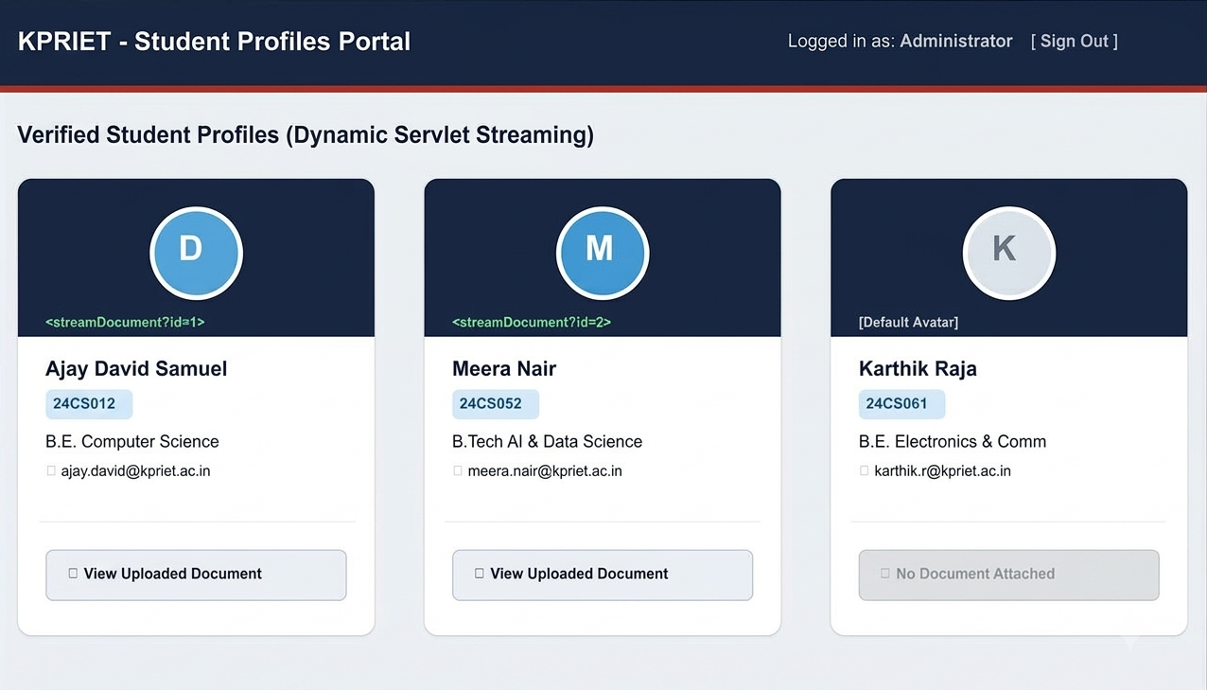

RESULT:
A Java Web Application was successfully developed using Servlets, JDBC, and JSP. The application connects to MySQL via JDBC, streams profile images and documents dynamically to <img> tags using StreamDocumentServlet, displays student profile cards using dynamic JSP looping and conditional statements, and enforces strict HTTP session security to prevent unauthorized access.

